How to Host a When I’m 65 Screening & Conversation

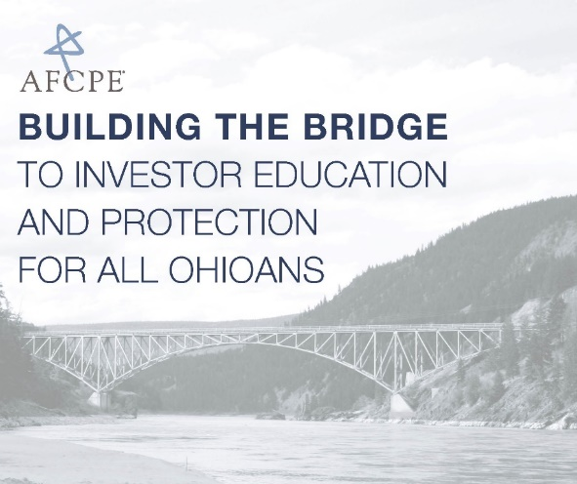
Whether you’re 25 or 55, now is the time to plan for the future and start your journey to financial stability.
As an organization, AFCPE® is dedicated to building the bridge to a more comprehensive and integrated continuum of care for financial services, ensuring that all people – regardless of age, income or background – can plan for a secure future. One way we do this is by building community - bridging the gaps between financial professionals and consumers.
Your voice and participation matter! As part of the Building the Bridge conversation, you are raising awareness about the importance of financial security, and are helping to make a positive difference in your community by linking people to needed resources and professionals.
What you’ll need:
- Access to Detroit Public Television’s When I’m 65 documentary
  - Check your local PBS schedule: http://wosu.org/television/schedule/
  - Stream the video online from www.wi65.org
  - Use the When I’m 65 DVD
- 1.5 - 2 hours
- A group of 8-10 people
  - Invite your neighbors, colleagues, family, or friends
  - Hosting a larger group? Consider breaking into smaller groups for more discussion time
How to prepare:
- Preview the documentary
- Highlight key quotes from featured experts and other content from the documentary for discussion
- Download resources: www.wi65.org/ohio
- Select a comfortable space
- Provide snacks and drinks for your guests
- Have paper and pens available for those who want to take notes
Starting the Conversation:
- Allow your guests to introduce themselves
- Watch the documentary
- Utilize the data points and discussion questions below
- Allow time in the discussion for additional questions from the group members
Discussion Questions:
- What kinds of financial lessons did you learn growing up?
- What messages are we passing on?
- Do you consider yourself more of a spender or a saver?
- We are bombarded with marketing messages about what to buy. How can we combat those messages and focusing on needs vs. wants to live within our means?
- What role do systemic factors like race and gender play in the challenge of getting out of poverty, living debt-free, or saving for retirement?
- What are the biggest financial challenges that derail efforts and good intentions to save?
- How can technology play a role in helping people save?
- What are the policy implications and solutions that would help solve these problems?
Data Points:
- Only 24% of Ohio residents who received a “million-dollar windfall” would use most of the money to save or invest for retirement. Nearly a third (32%) would instead pay off debts and another 3 in 10 would share much of the money with family members.
- Only two in 5 (41%) of Ohio adults have a financial plan they are following. Of the balance, 14% have not planned, 12% are just starting to plan for retirement, and about a quarter (23%) started but “had to stop because money was needed for other reasons”. Women in Ohio are more likely than men to have not started planning for retirement by a margin of 18% to 10%. African Americans are far more likely than whites not to have started planning for retirement by a margin of 29% to 12%.
- In Ohio, 53% of individuals lack a rainy-day fund to cover expenses for three months, in case of emergencies such as sickness, job loss or economic downturn. Individuals without this emergency fund lack adequate protection against financial emergencies or other shocks which may threaten their financial stability.

Creating action through conversation:
Have the group discuss:
- What personal actions group members will take to make change in their own lives?
- How group members can make change through advocacy on issues that impact financial security?
Resources:
Connect group members with local resources and qualified, trusted professionals.
www.wi65.org/ohio  www.iinvest.org/tools-resources/  www.afcpe.org | www.com.ohio.gov/secu  https://brokercheck.finra.org  www.afcpe.org/find-an-afc

This program would not be possible without funding from Investor Protection Trust (IPT); partnership and support from

the Ohio Division of Securities and Consumer Action; and Detroit Public Television, WOSU Public Media,

ThinkTV, and IdeaStream for their support with the documentary and engagement events.

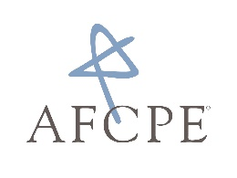
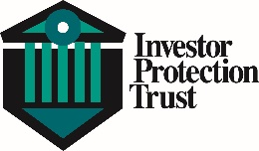
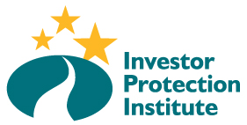
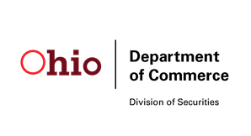

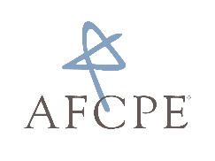
About Association for Financial Counseling & Planning Education® (AFCPE®): AFCPE® is the nationally recognized leader in financial counseling, coaching and education. Bringing together research, education and practice, we ensure the highest level of knowledge, skill and integrity of the personal finance profession by certifying, connecting and supporting diverse and capable professionals who serve communities worldwide.

